The Redesign of a Motorized Toy Car by Adapting the Throttle & Steering Controls to Engage Via a Joystick

User Manual & Guidelines
The Snow Munchers
April 26, 2026

User Manual Outline

- Table of Contents
- Introduction – Pg. 1
  - Scope
  - Safety Warnings & General Guidelines Prior to Assembly
- Package Contents – Pg. 3-4
  - Figures 1-8 & Table of Labeled Packaged Contents
- Materials & Tools Required – Pg. 4
  - List of Tools Needed
- Procedures for Assembly & Operation – Pg. 5-6
  - Assembly
  - Operation
- Maintenance Guideline – Pg. 6
- Storage Guideline – Pg. 7
- Troubleshooting Guideline – Pg. 7
- Technical Support – Pg. 7
- Spare Sparts & Components – Pg. 8

- Introduction
  - Scope
This user manual contains guidelines for the installation of a joystick onto a “Bestchoiceproducts’ SKY908” children’s rechargeable toy car for adaptive use. This kit changes the manner of directional control of the car using a joystick, which replaces both the throttle pedal and steering wheel to allow children with limited mobility to operate the car intuitively and independently. After reading this manual, a knowledgeable adult should be able to assemble the system and allow children to operate it safely. This product was designed with the best intentions to help kids be kids.
  - Safety Warnings & General Guidelines Prior to Assembly
Read this manual before assembling this product to understand proper operation, assembly, installation, troubleshooting, and safety concerns. This product must be assembled and installed by an adult with the proper tools and knowledge. It is important to avoid the elements from contacting any electrical components... no direct water or heat exposure. Please store this product in a cool, dry place to avoid the risk of damage to you, your children, and belongings.
Please be advised: YOU are modifying an existing product; the Snow Munchers are not liable for injuries caused by YOUR modifications. After implementing this product onto your existing car, the parental controls will NOT be operational... parental supervision is strongly advised for the participating child or children.

⚠ PLEASE NOTE THE WARNINGS INDICATED BY THIS SYMBOL: ⚠

- Package Contents
This product comes with the following equipment and components in the figures below:
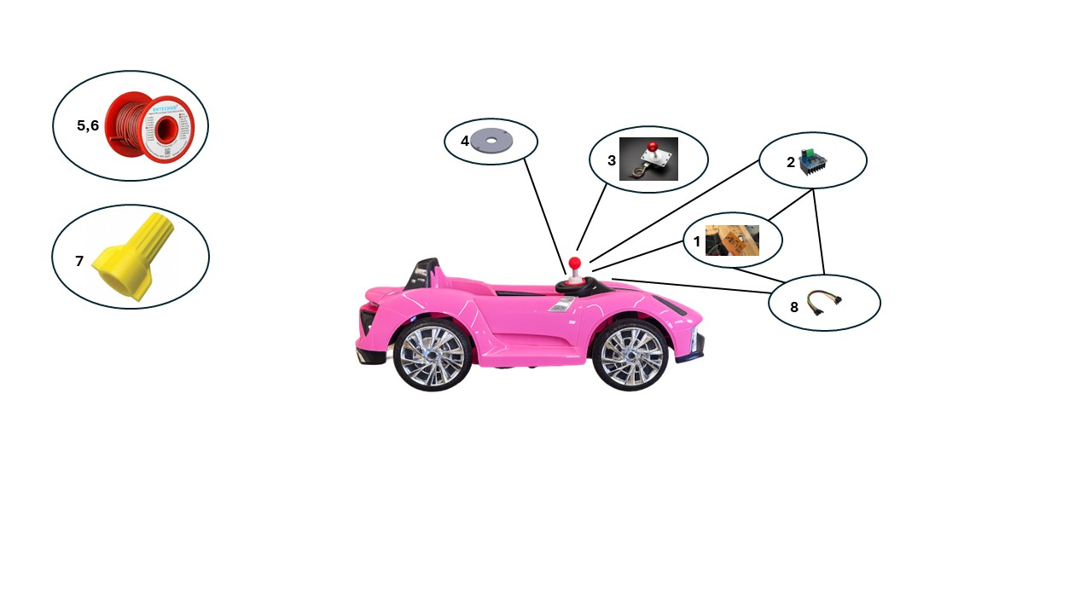

No. | Name of Part(s) | Qty.
1 | Circuit Board | 1
2 | IBT-2 H-Bridge Motor Controller | 3
3 | Joystick | 1
4 | Joystick Mount | 1
5 | 20 AWG Red Wire | 1
6 | 20 AWG Black Wire | 1
7 | Yellow Wire Nuts | 18
8 | Female to Female Jumper Wires | 24
9 | User Manual | 1

- Materials & Tools Required
  - List of Tools Needed
- Wire cutters/strippers.
- Phillips head screwdrivers (PH1.5 - PH4)

Please note: Not all materials and tools required for the assembly of this adaptation are provided in this kit. Fundamental wiring and assembly skills are required for the assembly of this project which will consist of stripping/cutting wire and screwing/unscrewing nuts and bolts. Please allow an adult who is familiar with said skills to carefully complete the assembly.

- Procedures for Assembly & Operation

⚠ ALWAYS ENSURE THE BATTERY IS DISCONECTED BEFORE WORKING WITH ANY ELECTRICAL COMPONENTS ⚠
  - Assembly️
- Test all H-Bridge, joystick, and other electrical components before assembly

- Remove the steering wheel. Look for a bolt at the base of the steering wheel and remove it. Unplug the wire and remove the steering wheel by pulling it up. Set aside.
- Remove the dash by removing the screws in the four corners using a Philips head screwdriver. Unplug the wires attached to the right of the dashboard. Set aside.
- Remove the cotter pin and washer at the front of the car, under where the dashboard used to be. Remove the screws that are adjacent to the washer.
- Flip the car over
- Remove the front axle assembly (seen in Figure 1).
  - Take out the four frame screws holding it to the frame.
  - Remove the cotter pin and washer at the base of the steering rod.
  - Lift the assembly up, set aside
Frame Screws
Steering Motor Bracket
Figure 1: Bottom of Front end of car
- Remove the steering motor bracket attached by a screw on either side (seen in Figure 1 above). Unplug the blue/brown wire attached to the steering motor. Pull the steering motor out and set aside.
- Flip the car right-side-up.
- Cut the Wires at the rear drive motors leaving 4 inches of wire attached to each motor. Do the same with the steering motor.
  - To find the rear drive motors (seen in Figure 2), move to the rear and look for a black and red wire set, under where the seat used to be.
Driver Motor wires
Relay
Figure 2: Rear Compartement located under seat
- Remove the relay mounted in the rear (seen in Figure 2 above) of the car attached by a single screw. Unplug all attached wires. Set aside.
- Cut the wires on the battery wire assembly, ensure to keep some things attached:
  - The fuse that is located on the orange wire.
  - The charging port attached via a plug
  - Both connectors that attach to the battery
  - 4 inches of wire on either side, past the already stated components.
- (optional) Remove all the remaining wires in the car OR leave them in incase of future retrofitting
- Cut the steering rod to allow room for joystick. Using a bandsaw, cut off just above where the cotter pin is inserted from the car side of the rod.
- Remove the back panel on the dashboard. Remove any wires ensuring to keep about 2 inches of wire on the start button.
- Flip the car upside down and reattach the steering motor, ensuring:
  - The wires from the motor now go through the body, up to where the dashboard was placed.
  - All screws are properly tightened.
  - The cut steering rod is placed back into its former spot
  - The wheels are mounted properly.
- Flip the car back up and attach the cotter pin and washer to the top of the steering rod
- Screw in the steering motor mount.
- Mount the joystick to the dashboard using the mount and mounting bolts.
  - Place the joystick on the inside of the dash, pointing out through the hole in the center. Place the mount on the other side of the dashboard and thread the bolts through the mount, dash, and joystick. The result should match that of Figure 3.
Figure 3: Mounted Joystick
- Route the power wires from the battery to the front of the car. There are two power wires, a black and a red, and both split into four wires on the end. Ensure that the split end ends up in front of the car.
  - Start at the front, feeding the single wire end into the hole (Figure 4) located to the right of the dashboard
Figure 3
Figure 4
  - Route it above the black structural beams on the bottom of the car
  - Feed it through the hole in the rear that leads to the compartment under the seat (Figure 4).
- Route wires from the rear drive motors to the front of the car as well, making use of the same holes used in step 19.
- Place the motor drivers on the shelves located on either side of the steering column, one on the left and two on the right.
- Begin attaching wires. Start by hooking up the steering motor driver, located to the left of the steering column. The brown wire should be attached to the M+ and the blue wire to the M-. Attach one of the logic wires, ensuring the black goes to the GND slot on the driver. Plug in the power wires, red to B+ and black to B-. Attach the other end of the logic wire to the PCB plug in labeled steering, ensuring the black goes to GND.
- Do the same for each rear motor, plugging the logic wire into the PCB plug ins labeled left drive and right drive respectively. The result should look something like Figure 5.
Figure 5: Wiring under dashboard
- Now, attach the power converter to the last remaining power and ground wire with the supplied wire nuts. Attach the plug in the other end of the power converter to the PCB port labeled VCC
- Attach the joystick wire into the PCB plug in labeled JYS, ensuring the red wire is on top (closest to the JYS label).
- Re-mount the dashboard using the screws set aside earlier.
  - Operation
- To operate, start by pressing the power button.
- To go forward, move the joystick up
- To go backward, move the joystick down
- To turn left, move the joystick left
- To turn right, move the joystick right

- Maintenance Guideline

- Ensure the H-bridge correctly switches motor directions.
- Verify all directions: forward, backward, left, and right.
- Confirm that the motors stop when the joystick is released in any direction; this ensures the electrical system is operating as intended before use.
- Recharge the battery properly according to your specific battery manufacturer’s instructions.
- After any electrical maintenance, perform a test with an unloaded car (wheels are off the ground).
- Components should be visually inspected bi-monthly to check for natural wear or abnormal wear.
- Verify correct motor polarity by observing wheel rotation direction in response to forward and reverse inputs.
- Confirm that H-bridge outputs switch cleanly between states without simultaneous activation of opposing signals.
- Perform a post-maintenance electrical test by measuring supply voltage and checking for stable current draw during operation.
- Inspect all wiring connections for continuity, secure termination, and absence of loose or exposed conductors.
- Conduct a functional driving test after maintenance to ensure proper system response under load conditions.

- Storage Guideline

⚠ PLEASE STORE THIS PRODUCT IN A COOL, DRY PLACE AND READ BELOW ⚠

- When the product is not in use, please have a knowledgeable adult disconnect the 12V power supply.
- Electrical components in this kit, such as the motor controllers, circuit board, and joystick, can develop corrosion if not stored in a cool dry place... resulting in damaged components and potential danger such as fire risks.
- It is also recommended that a knowledgeable adult tests battery voltage using a multimeter between every other charge session to ensure the battery is operating as intended.

Please note: The general temperature recommendation for storing a 12V battery can range from 41F°-68F°. As a general guideline, low temperatures can result in a decrease in battery performance, lifespan, and capacity. Allowing the battery to fully discharge may also result in damage. Please follow the guidelines provided by your specific battery manufacturer.

- Troubleshooting Guideline
- Steering Problems:
  - Steering in wrong direction
    - Swap the M+ and M- wires attached to the steering motor driver.
  - Not steering enough
    - Ensure there are no wires blocking the wheels from steering far enough
    - Ensure the steering rod is attached properly
- Drive Problems:
  - Motors turning in opposite directions
    - Swap the M+ and M- wires attached to ONE of the rear motor drivers
  - Move backwards when forward pressed
    - Swap the M+ and M- wires attached to BOTH rear motor drivers
  - Left and right control forward and backward
    - Ensure the joystick wire is attached to the PCB with red on top.
- Technical Support

⚠ IF AN EMERGENCY OCCURS DURING ASSEMBLY OR OPERATION CALL 911 IMMEDIATELY AND SAFELY DISCONNECT THE POWER SUPPLY IF POSSIBLE ⚠

For assistance with any minor issues, please refer to the Troubleshooting - Pg. 7 section of this manual.
For major problems, questions, or concerns please contact: cpkasayka@mavs.coloradomesa.edu

- Spare Parts & Components
- Supplied spare parts include
  - 3 additional wire nuts
  - 3 feet of 20AWG wire
  - An extra female-female logic connector wire

